## Team **Grapes**

## Task 1

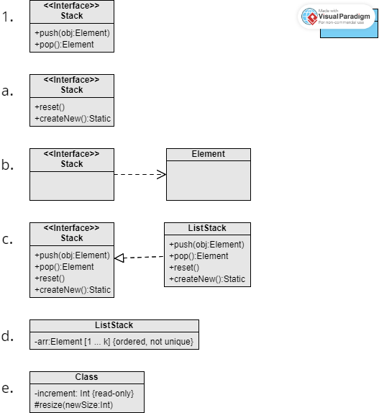

Task 2

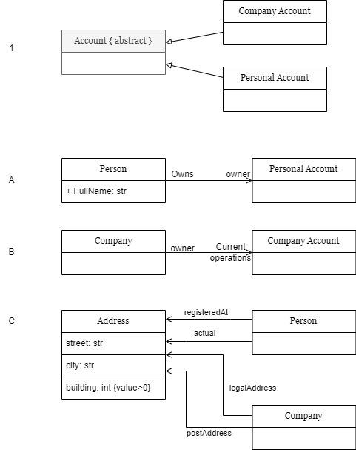

## 

## 

## Task 3

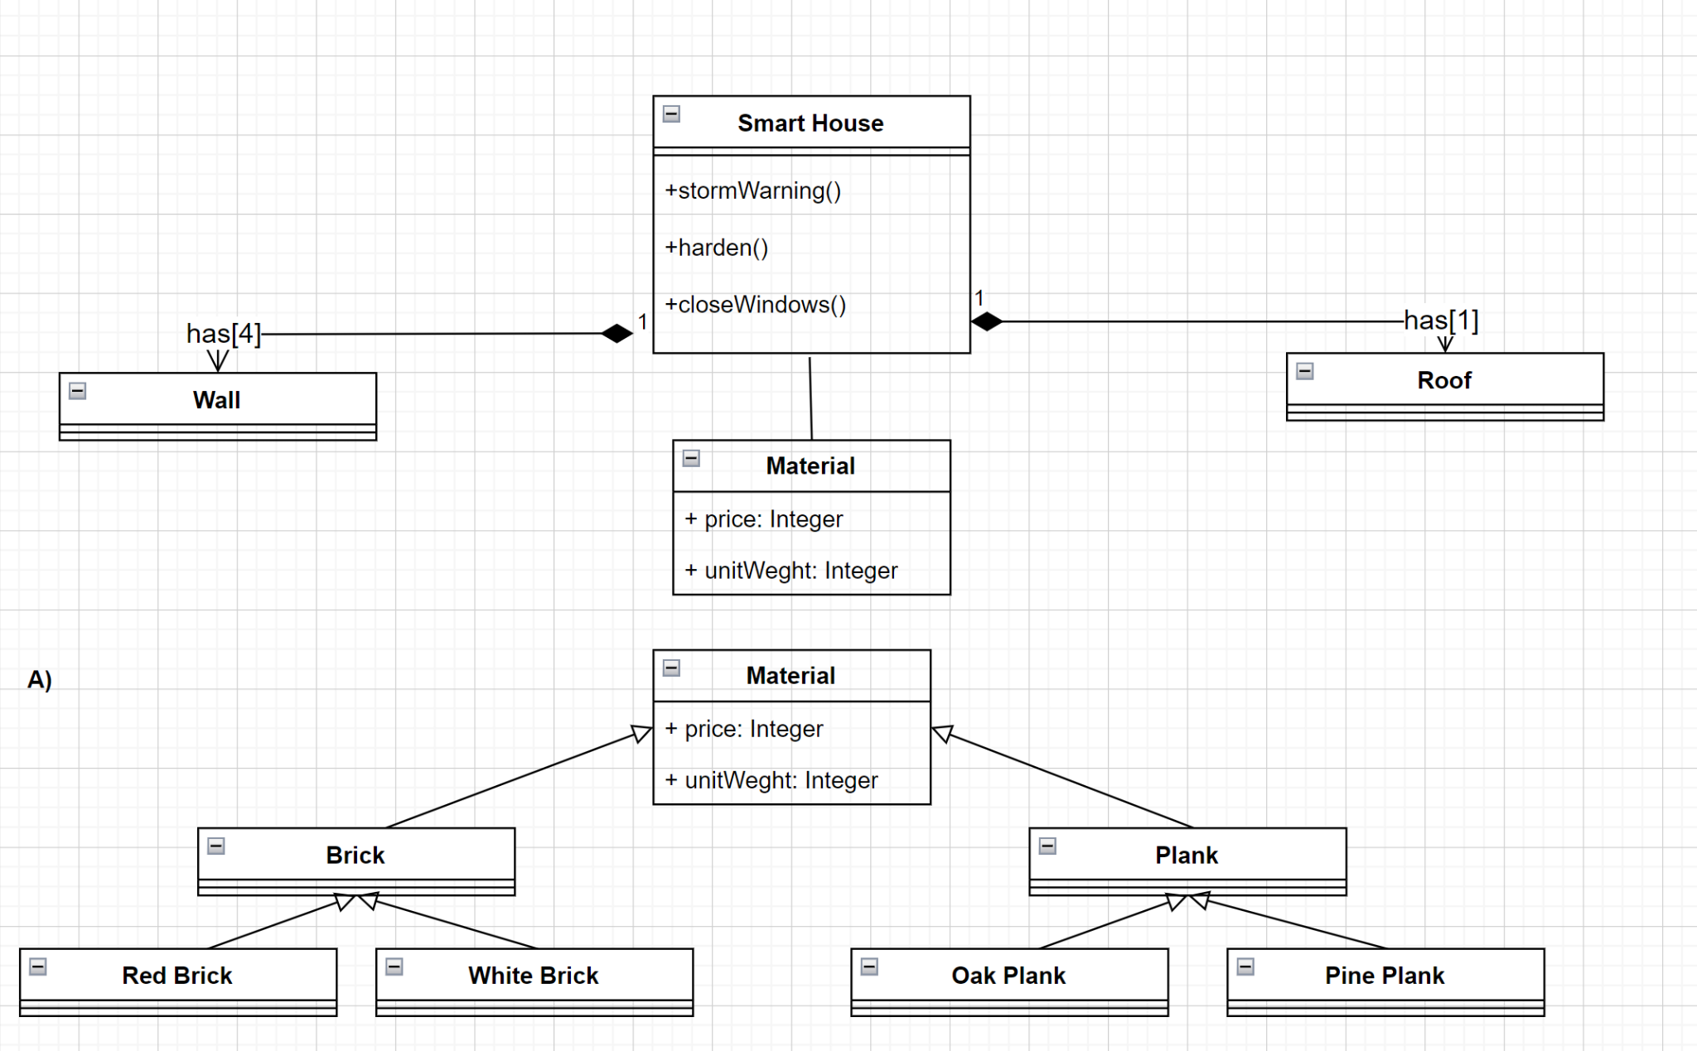

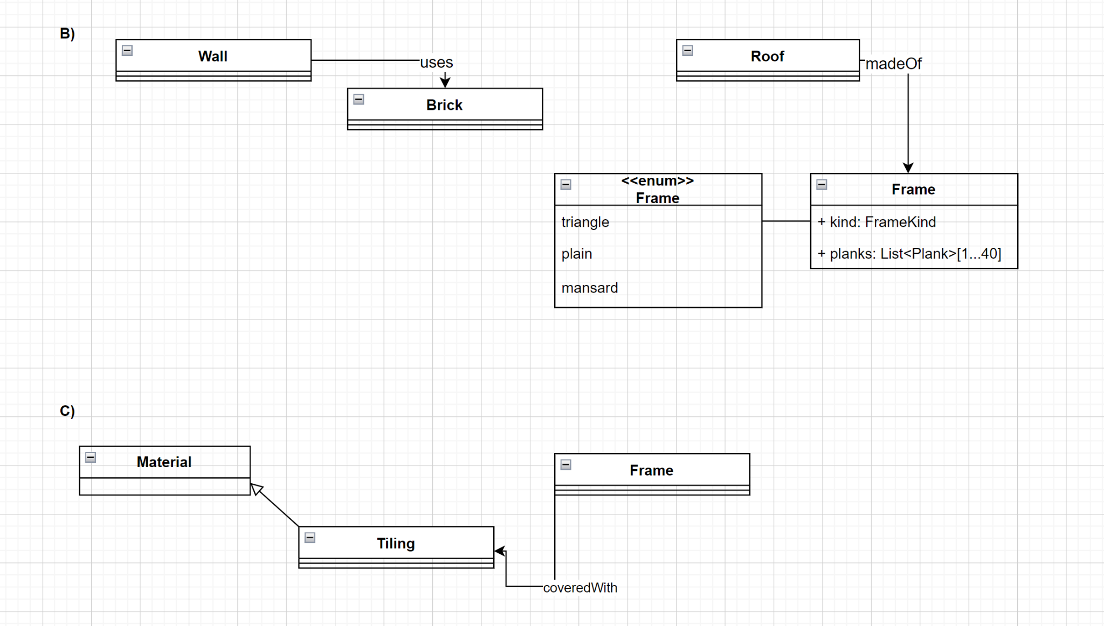

## **D)** Instances of the universal material will be equal to the number of different material types from the task

INSTANCES = Tilling for Roof Frame + Planks for Roof Frame + 4 * (Bricks for Wall)

## 

## Task 4

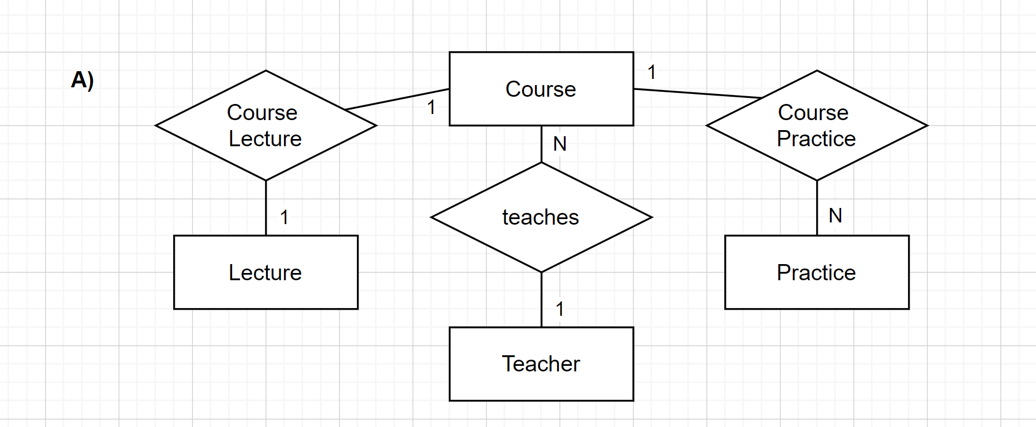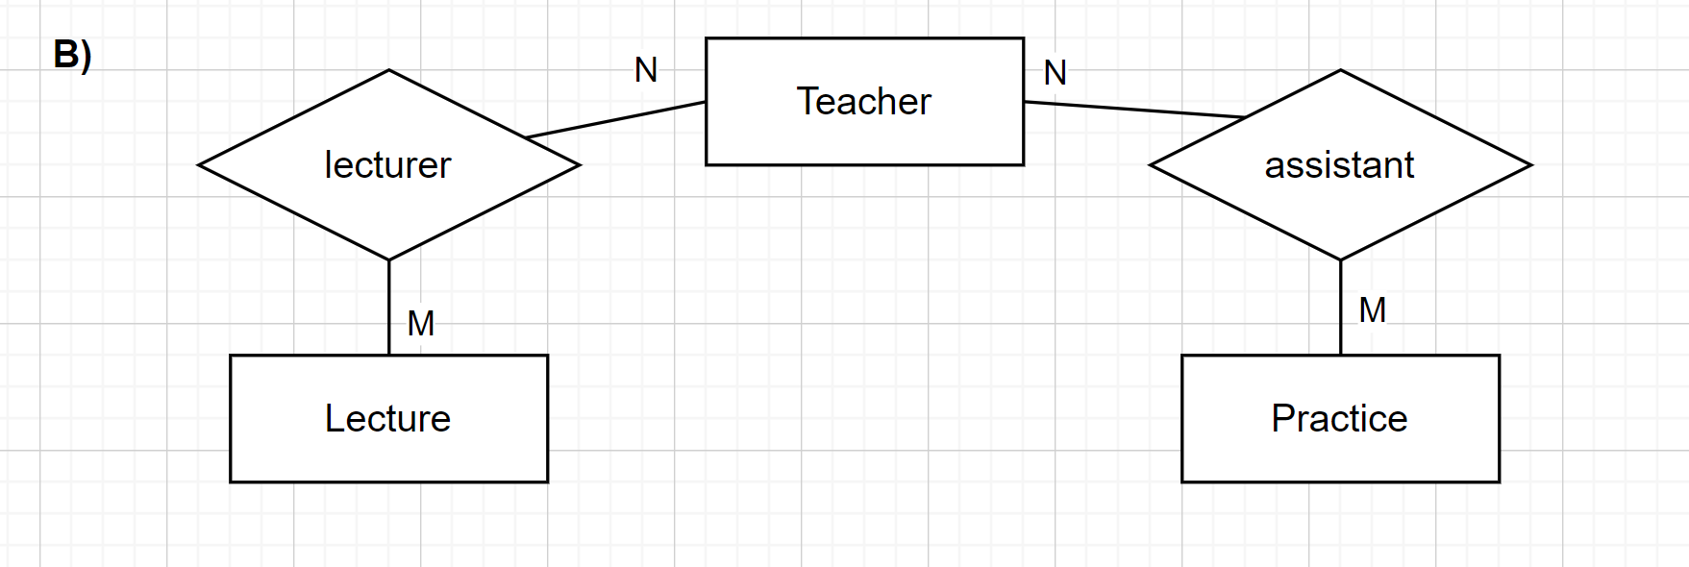

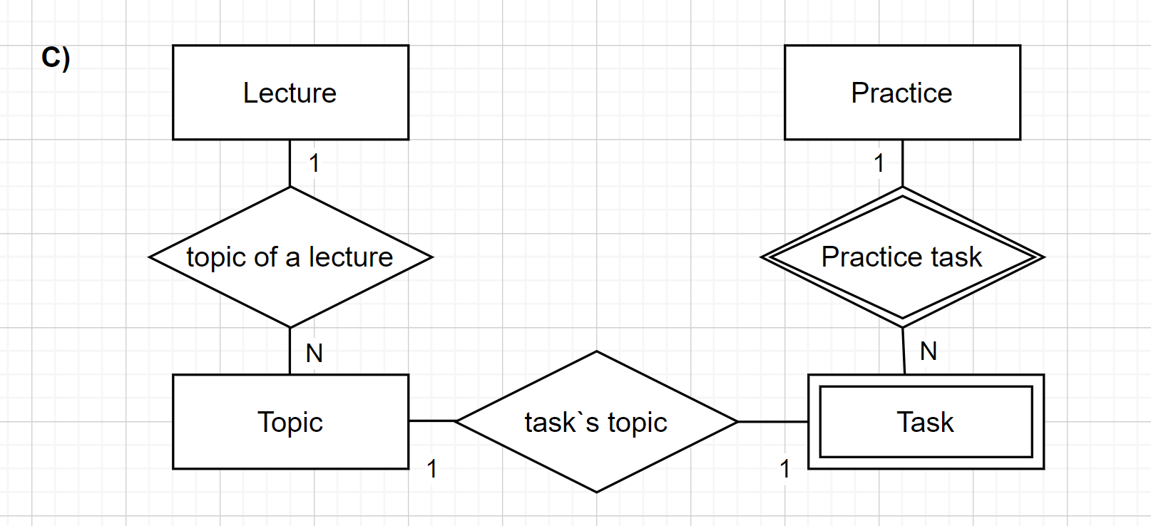

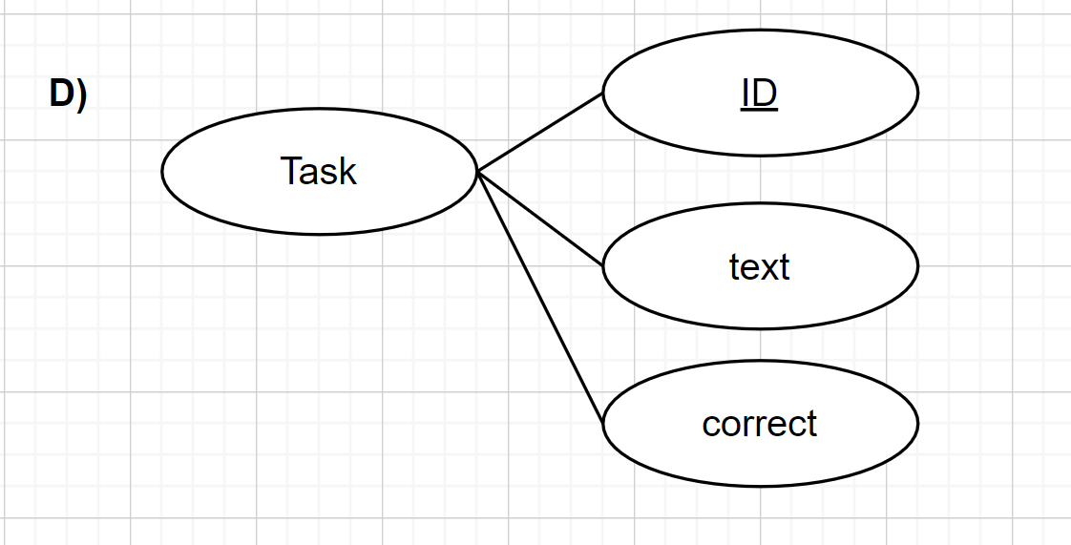

## Task 5

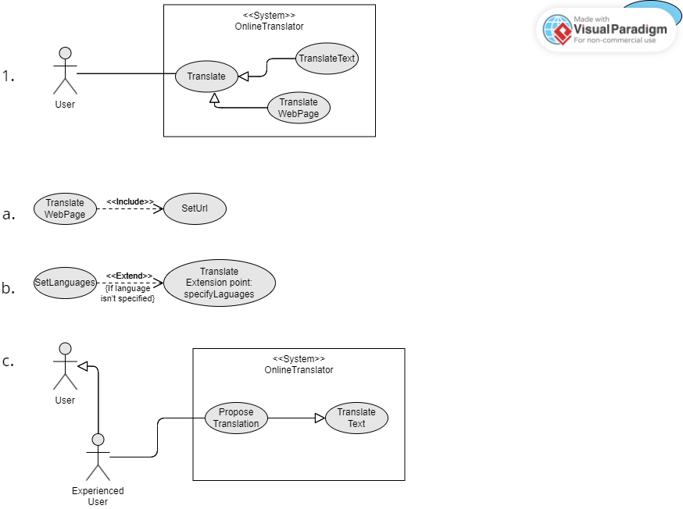

## Task 6

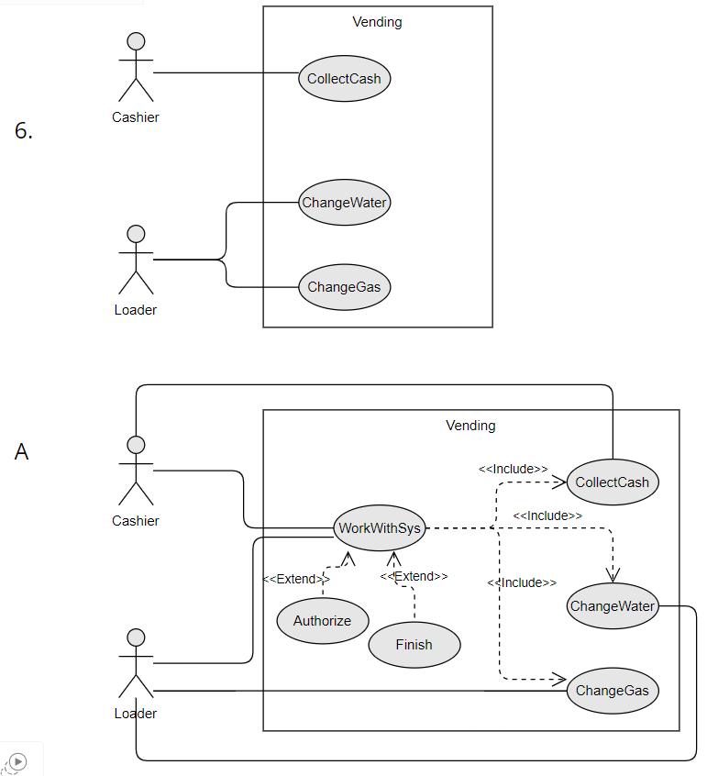

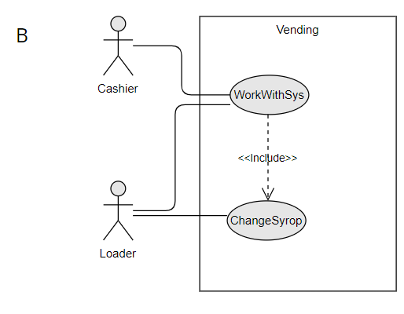

Cahier can change water if water in the machine is ended and it's no Loader with him.

That's so because the machine needs to be able for customers. And an operation doesn't need special rights

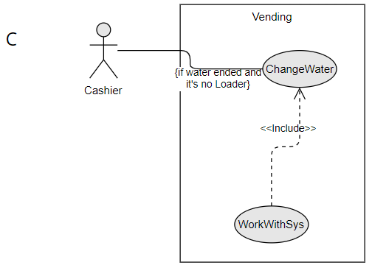

1 - entering the system the cashier can watch video, recorded by camera

2 - to record the video we add a new actor - Camera. it’s only Use Case is to Record Video

3 - Also we need a Sensor to activate the Camera, when somebody is near the vending machine

